Pre-Spring

CGI (Common Gateway Interface) :

## **• Client Request: The client (browser) sends an HTTP request to the web server.**

## **• Server Processing: The web server receives the request and identifies it as a CGI request.**

## **• CGI Script Execution: The server executes the CGI script, which can be written in languages like Perl, Python, or C (dependent language).**

## **• Data Processing: The CGI script processes the request, interacts with databases or other resources, and generates the required output.**

(by starting new process 🡪 processor load)

## **• Response Generation: The CGI script sends the output, usually in the form of HTML, back to the server.**

## **• Client Response: The web server sends the generated HTML back to the client as the HTTP response. (more users 🡪 load on server (slow)).**

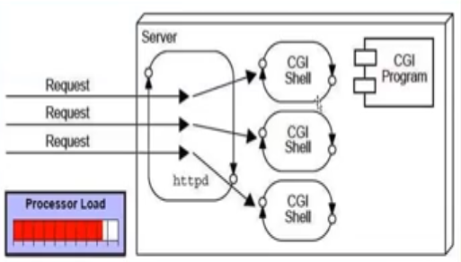

Servlet:

* **Java programs (java language only) that run on the server to generate dynamic web content efficiently.**
* **Depends on JVM.**
* **Secured.**
* **Is garbage collected by garbage collector of JVM.**

• Client Request: The client (browser) sends an HTTP request to the web server.

• Server Processing: The web server receives the request and identifies it as a servlet request.

• Servlet Loading: If the servlet is not already loaded, the server loads the servlet and initializes it.

• Request Handling: The server creates an instance of HttpServletRequest and HttpServletResponse.

• Servlet Execution: The server calls the servlet's service() method, passing the request and response objects.

• Data Processing: The servlet processes the request, interacts with databases or other resources, and generates the required output.

*Can receive many requests & using Multithread to process (less processor load).

• Response Generation: The servlet sends the output, usually in the form of HTML, back to the server.

• Client Response: The web server sends the generated HTML back to the client as the HTTP response.

🡪After Servlet terminated calls destroy() method .

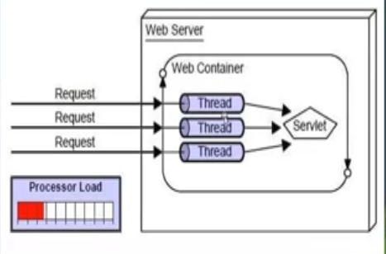 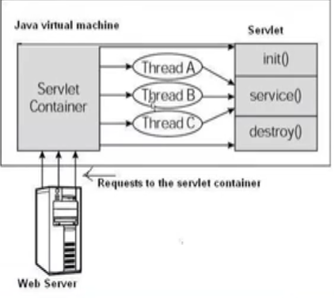

Get & Post

